USVI SOCCER ASSOCIATION PRESS RELEASE

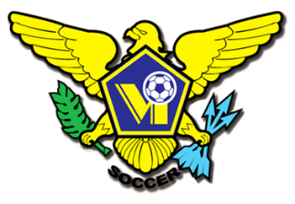

[This Photo](https://en.wikipedia.org/wiki/United_States_Virgin_Islands_national_soccer_team) by Unknown Author is licensed under [CC BY-SA](https://creativecommons.org/licenses/by-sa/3.0/)



[This Photo](https://en.wikipedia.org/wiki/United_States_Virgin_Islands_national_soccer_team) by Unknown Author is licensed under [CC BY-SA](https://creativecommons.org/licenses/by-sa/3.0/)



[This Photo](https://en.wikipedia.org/wiki/United_States_Virgin_Islands_national_soccer_team) by Unknown Author is licensed under [CC BY-SA](https://creativecommons.org/licenses/by-sa/3.0/)



[This Photo](https://en.wikipedia.org/wiki/United_States_Virgin_Islands_national_soccer_team) by Unknown Author is licensed under [CC BY-SA](https://creativecommons.org/licenses/by-sa/3.0/)

OFFICE: 340.719.9707 23-1 Estate Bethlehem, Kingshill, St. Croix 00850

[USVISOCCERASSOCIATION@GMAIL.COM](mailto:USVISOCCERASSOCIATION@GMAIL.COM) FACEBOOK/USVI SOCCER ASSOCIATION

**October 03, 2022**

**Press Release:**

**USVISA Grassroots Program open registration**

The U.S. Virgin Island Soccer Association Grassroots program is where the future USVI Soccer player will start their path to success. Our goal is to produce quality national players and to consistently have successful/winning national teams play in regional and international competitions at all age categories for both males and females. The 2022/23 season kicks off on Saturday October 22, 2022

Parents of children 5-13 years old are invited to register for one of our locations throughout the territory.

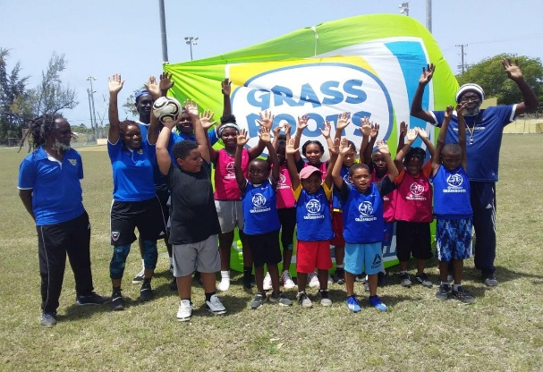

The program takes place on Saturday Mornings 9:00AM – 11:00AM.

On St. Croix at the Bethlehem Soccer Complex.

On St. Thomas at two locations -

UVI Athletic Field

Smith Ball Park

Registration/insurance - $25.00, mandatory.

Practice uniforms - $25.00, optional.

**Athletic shoes and clothing must be worn at sessions.

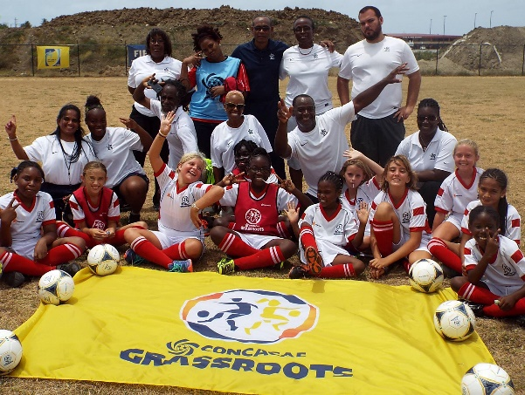

At USVISA we want children to learn the game and grow to love it. We want their self-confidence to soar like eagles!

Our coaches and facilitators are trained to observe and stimulate your child’s growth and development.

The entry level soccer sessions are designed to be fun outdoor activities that get children moving, making friends, gaining life skills, and become great citizens.

For more information on USVI Soccer Association programs, please feel free to contact the USVI Soccer Association office at (340)-719-9707 or email us at [usvisoccer@gmail.com](mailto:usvisoccer@gmail.com). Follow us on Facebook at: USVI Soccer Association